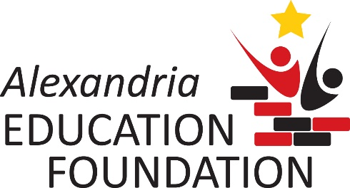

Letter of Intent – 2018-2019 Grant Year
Teacher Innovation Grant

To eliminate requests that will not be considered, usually due to other available sources of revenue or not meeting the grant criteria, persons wishing to apply for a grant from the Alexandria Education Foundation (AEF) are asked to submit a Letter of Intent to AEF by Friday, March 2, 2018.

Applicants will be notified if their letter of intent has or has not been accepted no later than March 9. If you are invited to submit a full grant application, the invitation will include the full application, instructions and the due date.

If you have any questions about whether your idea is suitable for funding, please contact Jean Bristow, Foundation Board Member at mikeandjean@charter.net or 320-491-8676.

Brief summary of project: (no more than 2 paragraphs)
Click or tap here to enter text.

AEF Criteria Met by this Project: (check all that apply)
☐Project will encourage and facilitate innovative ideas and teaching practices.
☐Project will enrich learning in the classroom.
☐Project will promote collaboration and the exchange of ideas.
☐Project will further district initiatives and curriculum goals.

Outcomes: (list at least 2)
Click or tap here to enter text.

Grant Amount Requested: Click or tap here to enter text. (Minimum $500.00 / Maximum $10,000.00)

Primary Applicant signature: Co-Applicant signatures, if applicable:

_____________________________________ ___________________________________

Signature of Building Principal and/or Administrator approving this request:

______________________________________________________ ___________
Date

Please email this form to: mikeandjean@charter.net.

